

IRF21/2779

Gateway determination report – PP-2021-4263

Wollongong City Centre Heritage Amendments

July 21

Published by NSW Department of Planning, Industry and Environment

[dpie.nsw.gov.au](http://www.dpie.nsw.gov.au/)

Title: Gateway determination report – PP-2021-4263

Subtitle: Wollongong City Centre Heritage Amendments

© State of New South Wales through Department of Planning, Industry and Environment 2021. You may copy, distribute, display, download and otherwise freely deal with this publication for any purpose, provided that you attribute the Department of Planning, Industry and Environment as the owner. However, you must obtain permission if you wish to charge others for access to the publication (other than at cost); include the publication in advertising or a product for sale; modify the publication; or republish the publication on a website. You may freely link to the publication on a departmental website.  
  
Disclaimer: The information contained in this publication is based on knowledge and understanding at the time of writing (July 21) and may not be accurate, current or complete. The State of New South Wales (including the NSW Department of Planning, Industry and Environment), the author and the publisher take no responsibility, and will accept no liability, for the accuracy, currency, reliability or correctness of any information included in the document (including material provided by third parties). Readers should make their own inquiries and rely on their own advice when making decisions related to material contained in this publication.

Contents

1 Planning proposal 1

1.1 Overview 1

1.2 Objectives of planning proposal 1

1.3 Explanation of provisions 1

1.4 Site description and surrounding area 3

1.5 Mapping 3

1.6 Background 3

2 Need for the planning proposal 4

3 Strategic assessment 4

3.1 Regional Plan 4

3.2 Local 4

3.3 Local planning panel (LPP) recommendation 5

3.4 Section 9.1 Ministerial Directions 5

3.5 State environmental planning policies (SEPPs) 5

4 Site-specific assessment 6

4.1 Environmental 6

4.2 Social and economic 6

5 Consultation 6

5.1 Community 6

5.2 Agencies 6

6 Timeframe 6

7 Local plan-making authority 6

8 Assessment summary 6

9 Recommendation 7

Table Reports and plans supporting the proposal

| Relevant reports and plans |
| --- |
| Draft Planning Proposal: Wollongong City Centre – Heritage |
| Council Report (31 May 2021) |
| Wollongong City Centre Heritage Study (May 2021) |
| Map of the proposed additional heritage sites |

# Planning proposal

## Overview

Table 2 Planning proposal details

| LGA | Wollongong |
| --- | --- |
| **PPA** | **Wollongong City Council** |
| **NAME** | **Wollongong City Centre Heritage Amendments (0 homes, 0 jobs)** |
| **NUMBER** | **PP-2021-4263** |
| **LEP TO BE AMENDED** | **Wollongong Local Environmental Plan 2009** |
| **ADDRESS** | **Various (refer to Table 3)** |
| **DESCRIPTION** | **Various (refer to Table 3)** |
| **RECEIVED** | **2/07/2021** |
| **FILE NO.** | IRF21/2779 |
| **POLITICAL DONATIONS** | **There are no donations or gifts to disclose and a political donation disclosure is not required** |
| **LOBBYIST CODE OF CONDUCT** | **There have been no meetings or communications with registered lobbyists with respect to this proposal** |

## Objectives of planning proposal

The objective of this Planning Proposal is to list 19 additional local heritage items in Schedule 5 of the Wollongong Local Environmental Plan 2009 (Wollongong LEP) and the accompanying Heritage Map.

The objectives of this planning proposal are clear and adequate.

## Explanation of provisions

The planning proposal seeks to amend the Wollongong LEP 2009 by adding 19 additional local heritage items to Schedule 5 of the Wollongong LEP 2009 (**Table 2**).

Table 3 Heritage items to be added to the Wollongong LEP

|  |  |  |  |  |
| --- | --- | --- | --- | --- |
| **Item Name** | **Address** | **Property Description** | **Significance** | **Item No.** |
| Archaeological Site of Wollongong Gaol* | 84, 86, 88 Cliff Road and 3, 5 and 7 Hector Street | Lot 5, 6, 7, 8, 9 & 10 DP 11509 | Local | 61094 |
| Archaeological Remains of The Cricketers Arms Hotel* | Corrimal Street Road Reserve - corner of Crown Street adjacent to 26-28 Burelli Street | Lot 3 DP 1229693, Road Reserve, DP 1226160 & DP 153514 | Local | 61097 |
| Queens Hotel Archaeological Site* | 24 Crown Street (Market Street frontage) | Lot 5 DP 16847 | Local | 61101 |
| Group of Commercial Buildings on Crown Street (Front of building to 6m). | 98-102 Crown Street | Lot 1 DP 163231, Lot 1 DP 657047 | Local | 61106 |
| “Kawarra Chambers” | 118-124 Crown Street | Lot 4 DP 83910 | Local | 61105 |
| “Bank Chambers” (Front of building to 6m) | 127-131 Crown Street | Lot 1-3, DP 1070120 | Local | 61098 |
| Archaeological Site of Wollongong Gaol* | 84, 86, 88 Cliff Road and 2, 4 and 6 Robertson Street | Lot 5, 6, 7, 8, 9 & 10 DP 11509 | Local | 61094 |
| Archaeological Remains of The Cricketers Arms Hotel* | Corrimal Street Road Reserve - corner of Crown Street adjacent to 26-28 Burelli Street | Road Reserve | Local | 61097 |
| “Bank Chambers  (Front of building to 6m) | 127-131 Crown Street | Lot 1-3, DP 1070120 | Local | 61098 |
| Caldwell’s Building | 280-282 Crown Street | Lot 4 & 5 DP 29391 | Local | 61100 |
| Commercial Frontages (Front of building to 6m) | 135, 137-139 Crown Street | Lot 1 DP 603751, Lot 1 DP 546698 | Local | 61102 |
| Commercial Frontages (Front of building to 6m) | 179-189 Crown Street | Lot 1 DP 805952, Lot 1 DP 77246, Lot 1 DP 75289 | Local | 61103 |
| Commercial Frontages (Front of building to 6m) | 98-102 Crown Street | Lot 1 DP 163231, Lot 1 DP 657047 | Local | 61106 |
| Kawarra Chambers | 118-124 Crown Street | Lot 4 DP 83910 | Local | 61105 |
| Archaeological Site of the Queens Hotel* | 24 Crown Street | Lot 5 DP 16847 | Local | 61101 |
| Former “Berlei Building” | 43-47 Denison Street | Lot 32 & 33 Sec 4 DP 1258 | Local | 61095 |
| Federation House | 3 Hercules Street | Lot 24 Sec 3 DP 1258 | Local | 61093 |
| Interwar House | 11 Hercules Street | Lot 20 Sec 3 DP 1258 | Local | 61089 |
| Group of Commercial Buildings on Keira Street | 100-120 Keira Street | Lot 1 DP 129003, Lot 2 Sec B DP 9874, Lot 3, DP 217310, Lot 4, 5 & 6 DP 577095 | Local | 61096 |
| Gloucester House | 82-84 Kembla Street | Lot Y & Z DP 418904 | Local | 61099 |
| Marlborough Court | 4 Market Place | Lot 1 DP 1127347 | Local | 61088 |
| “Braemar” Flats | 29 Smith Street | Lot 8 DP 502120 | Local | 61090 |
| Kingston House | 27A Smith Street | Lot 3 DP 17682 | Local | 61091 |
| “Pious Society of St Charles Sacred Heart Church | 28 Stewart Street | Lot 126 DP 596582 | Local | 61104 |
| Seventh Day Adventist Church | 30 Victoria Street | Lot 20 Sec A DP 9874 | Local | 61092 |

The proposed new heritage items include three archaeological sites, two sites identified in the Wollongong Migrant Heritage Study and four proposed character ‘façade’ listings, as well as a range of sites that represent Twentieth Century Architecture.

The planning proposal contains an explanation of provisions that adequately explains how the objectives of the proposal will be achieved.

## Site description and surrounding area

The site comprises multiple properties in the Wollongong City Centre (**Figure 1**). The addresses of these items are contained in **Table 2**.

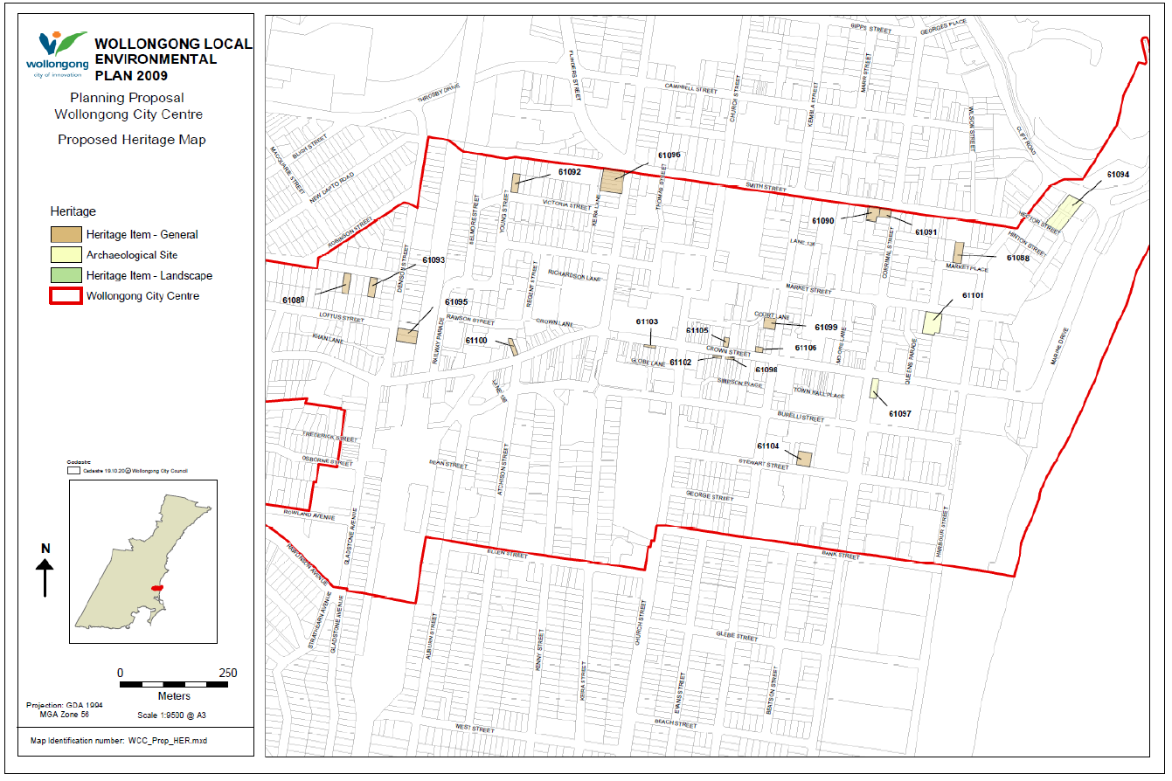

Figure Subject site (source: Planning Proposal)

## Mapping

The planning proposal includes existing and proposed draft heritage maps which are considered adequate for exhibition purposes.

## Background

This amendment forms part of Council’s ongoing review of the Heritage Schedule in the Wollongong LEP.

On 23 April 2021, an administrative amendment (Stage 1) was made to the Wollongong LEP to update the listing details of many heritage items across the Wollongong local government area (LGA).

Stage 2 of the review involves considering a range of potential new local heritage items across the LGA. Over 150 potential heritage items are being considered as part of Stage 2 of the review, which is expected to be progressed in late 2021.

Concurrently, on 21 September 2020, Council adopted the Wollongong City Centre Urban Design Framework. One of the outcomes of the Framework was to review the heritage listings and character buildings within the City Centre as part of the preparation of a new draft Planning Strategy.

In response to the recommendations of the Urban Design Framework, Council Officers prepared the Wollongong City Centre Heritage Study (May 2021). The Study draws together the City Centre components of Stage 2 of Heritage Schedule Review Project into a Precinct based Heritage Study.

The Study involved a detailed review of the history, character and development of the City Centre, and detailed consideration of the existing listings within the study area.

The study identifies gaps and opportunities to explore additional listings, and planning recommendations, to support positive conservation outcomes and retention of key character aspects across the study area. Incorporated into this review has been a backlog of nominations and potential heritage sites which have been gathered over several years from a range of sources.

The Study recommends listing of 19 items within the City Centre boundary (as proposed in this planning proposal).

# Need for the planning proposal

The planning proposal is needed to implement recommendations of the Wollongong City Centre Heritage Study undertaken by Council to ensure the heritage significance of the 19 identified items is protected.

The Department considers it important to protect local heritage and for this reason, is in principle supportive of planning proposals that protect local heritage items identified by Councils, consistent with local and regional strategic planning objectives.

A planning proposal of this nature is the only way to achieve the intended outcomes.

# Strategic assessment

## Regional Plan

The planning proposal is consistent with Objective 23 and Strategy 23.1 of the Illawarra Shoalhaven Regional Plan 2041 by identifying, conserving, and enhancing cultural heritage values.

The planning proposal addresses the previous Regional Plan and a Gateway condition is therefore recommended requiring the planning proposal to be updated prior to exhibition to address consistency with the Illawarra Shoalhaven Regional Plan 2041.

## Local

The proposal states that it is consistent with the following local plans and strategies. It is also consistent with the strategic direction and objectives, as stated in **Table 4** below.

Table 4 Local strategic planning assessment

| Local Strategies | Justification |
| --- | --- |
| Local Strategic Planning Statement | The proposal is consistent with Section 4.1.5 of the Wollongong Local Strategic Planning Statement (LSPS), as it:   * supports the recognition and protection of heritage values; and * is consistent with the Wollongong Heritage Strategy 2019-2021 and the accompanying Implementation Plan which identifies the Wollongong Heritage Schedule Review Project.   The planning proposal does not address consistency with Council’s LSPS and a Gateway condition is recommended accordingly. |
| Community Strategic Plan | The proposal is consistent with Council’s Community Strategic Plan as it will meet the objective “Community awareness and appreciation of heritage is increased” under the Community goal “we value and protect our environment”. |
| Wollongong City Centre Heritage Study | This planning proposal is an outcome of, and is consistent with, this Study. |

## Local planning panel (LPP) recommendation

Council advised the Wollongong City Centre Heritage Study was reported to the Wollongong Local Planning Panel on the 19 March 2021.

The Panel determined the draft planning proposal for the Wollongong City Centre Heritage Review had strategic merit and should be progressed.

The Panel suggested that the proposed listing of the dwelling houses at 3 and 11 Hercules Street should be revisited given the current controls (zoning, height and FSR) of the area.

The Panel was also of the view that the heritage listings should ideally be considered concurrently with draft Wollongong City Centre Planning Proposal or the draft Wollongong City Centre Planning Proposal should be revisited to have regard to this planning proposal.

Council staff intend to consider the feedback from the Panel in relation to the dwellings at 3 and 11 Hercules Street in conjunction public exhibition feedback, and in finalising a future report to Council.

Council has also confirmed the draft Wollongong City Centre Planning Proposal is yet to be finalised and the controls for affected properties will be reviewed if they are heritage listed.

The planning proposal document itself does not provide a response to the Panel’s advice. A Gateway condition is recommended requiring the planning proposal to be updated accordingly prior to exhibition.

## Section 9.1 Ministerial Directions

The proposal is minor in nature and is consistent with applicable Ministerial Directions, in particular Direction 2.3 - Heritage Conservation.

## State environmental planning policies (SEPPs)

The proposal is consistent with relevant SEPPs.

# Site-specific assessment

## Environmental

The proposal will support the appropriate consideration and protection of environmental heritage values.

## Social and economic

The proposal would have positive social impacts on the broader community by protecting heritage items.

Council acknowledged the proposal may have some social and economic impacts on affected landowners. Council advised these matters will be a key consideration of the public exhibition process and will be further considered in the post exhibition report to Council.

Council noted affected property owners have been notified of the progression of the Wollongong City Centre Heritage Study and the draft planning proposal and will be further invited to have formal input during public exhibition.

# Consultation

## Community

Council proposes a community consultation period of 28 days.

The exhibition period proposed is considered appropriate, and forms a condition of the Gateway determination.

## Agencies

Council advised the proposal does not affect any properties owned by State or Commonwealth authorities. Council has committed to inviting NSW Heritage to comment on the proposal.

A Gateway condition is recommended requiring the Department of Premier and Cabinet (NSW Heritage) be consulted on the planning proposal and given at least 21 days to comment.

# Timeframe

Council proposes a 9 month time frame to complete the LEP.

The Department recommends a time frame of 12 months to finalise the LEP in case any unforeseen issues arise.

# Local plan-making authority

Council has advised that it would like to exercise its functions as a Local Plan-Making authority.

As the planning proposal concerns local heritage matters, the Department recommends that Council be authorised to be the local plan-making authority for this proposal.

# Assessment summary

The planning proposal is supported to proceed with conditions as it is consistent with local and regional strategic planning objectives to protect heritage.

# Recommendation

It is recommended the delegate of the Secretary:

* agree that the proposal is consistent with applicable Ministerial directions and that no further approval is required.

It is recommended the delegate of the Minister determine that the planning proposal should proceed subject to the following conditions:

1. The planning proposal is to be updated prior to public exhibition to:

* address consistency with Council’s LSPS;
* address consistency with the Illawarra Shoalhaven Regional Plan 2041; and
* provide a response to the Wollongong Local Planning Panel’s advice of 21 March 2021.

1. Consultation is required with the following public authorities:

* Department of Premier and Cabinet (NSW Heritage).

1. The planning proposal should be made available for community consultation for a minimum of 28 days.
2. The timeframe for completing the LEP is to be 12 months from the date of the Gateway determination.
3. Given the nature of the proposal, Council should be authorised to be the local plan-making authority.

26/07/21

Graham Towers

Manager, Southern Region

27/07/21

Sarah Lees

Director, Southern Region

Local and Regional Planning

Assessment officer

Andrew Hartcher

Senior Planner, Southern Region

Attachment A – Planning Proposal

Attachment B – Gateway determination

Attachment C – Letter to Council